Round 2 - Prototype Data Report
Jacob Ray
Group No.3 - Evolve: LLM-Guided Evolutionary Algorithm for Pacman
Sweep: Population-size sweep

1. Parameter Configuration
This experiment tested the effect of population size on the Pacman evolutionary optimization task. The task was fixed to pacman, the selection mode was set to diversity, the number of generations was fixed at 4, top_k was fixed at 3, and the random seed was fixed at 42 to keep the runs reproducible. The only parameter changed across the experiment was population size. Four configurations were tested: A_pop_3 with population size 3, B_pop_5 with population size 5, C_pop_7 with population size 7, and D_pop_9 with population size 9. This setup allowed the comparison to focus specifically on how population size affected fitness improvement, runtime behavior, and the overall quality of the evolved Pacman solution.
Fixed parameters:
Parameter | Value
Task | pacman
Generations | 4
Population size | 3,5,7,9
Top-k / elite size | 3
Selection mode | diversity
Fitness preset | pacman
Seed | 42
Strategies per config | full, random_only
Population configurations:
Label | Population Size | Rationale
A_pop_3 | 3 | Small population, lower diversity
B_pop_5 | 5 | Moderate population, best-performing configuration
C_pop_7 | 7 | Larger population with more candidates per generation

1b. Run Evidence (UI Screenshots)
Screenshot 1 shows the live web UI configured for my population-size experiment on the Pacman task. The run uses diversity selection, 4 generations, top_k = 3, seed = 42, and compares the full LLM-guided strategy with the random_only baseline. The tested configuration shown in the screenshot is one of the population-size settings from the sweep.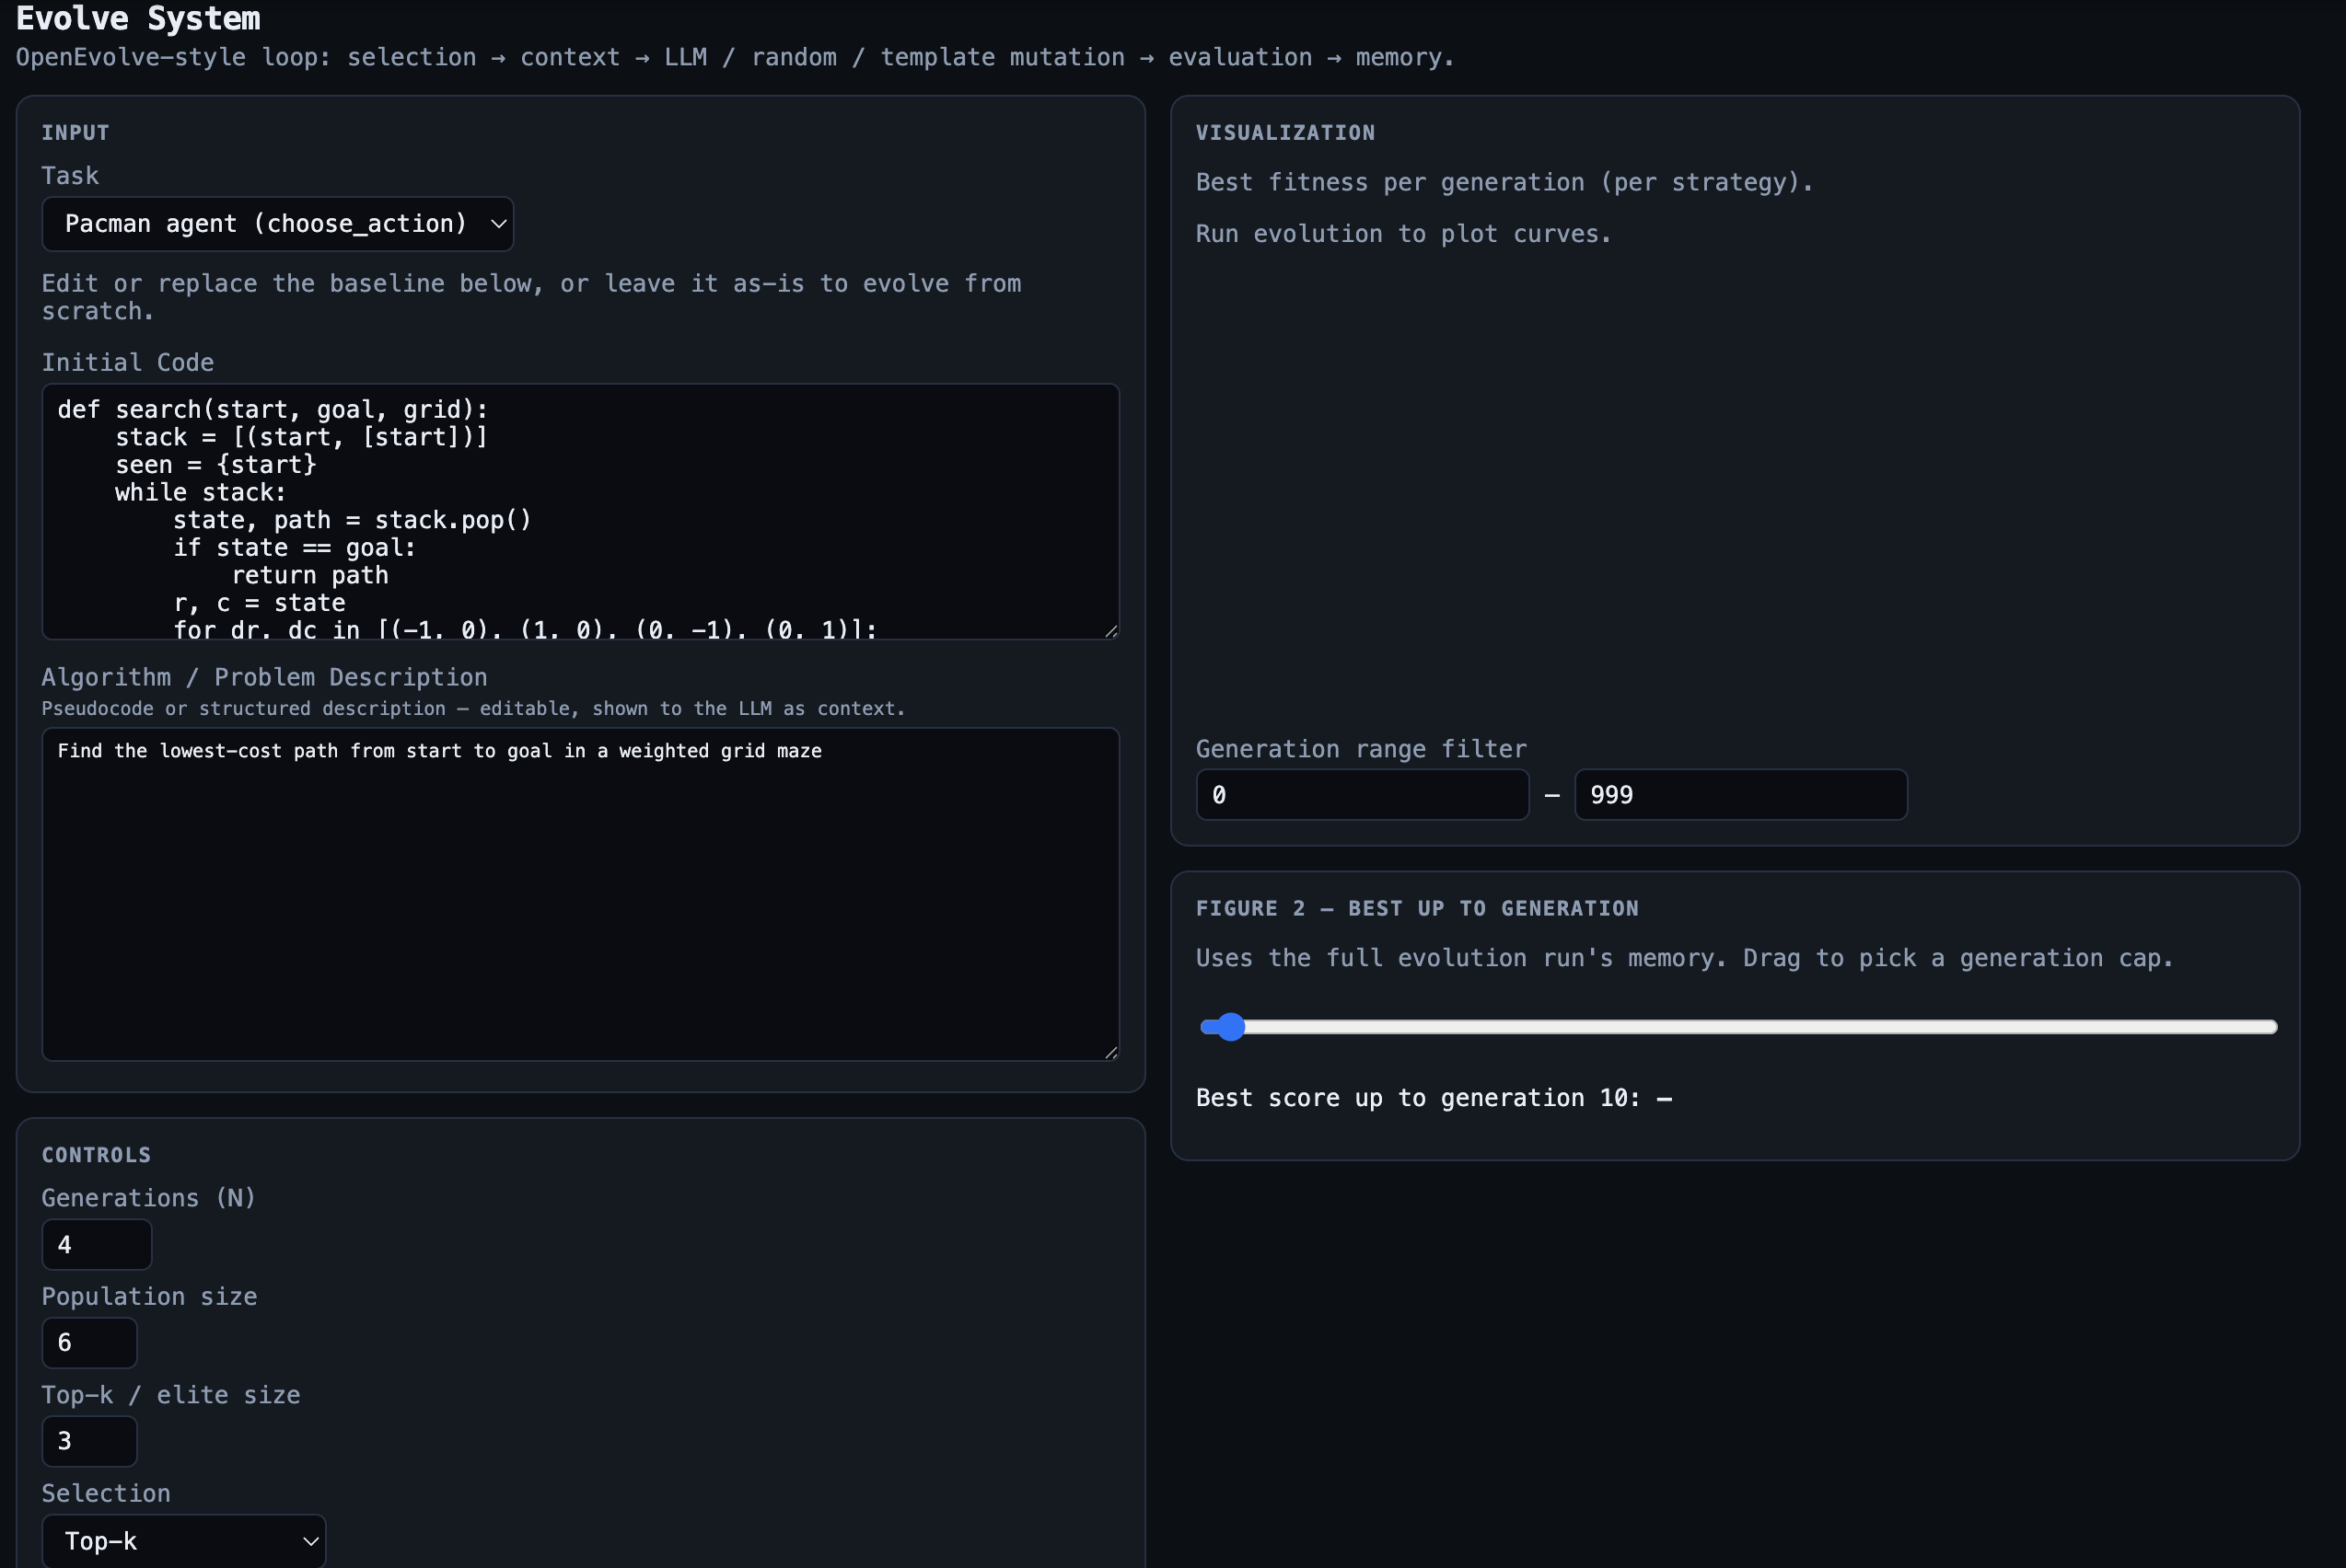
Screenshot 2 shows the same run after pressing Run Evolution. The interface displays the best-fitness curve, the per-generation Pacman metrics, the comparison summary between full evolution and random_only, the best evolved code, and the evolution history used for analysis in this report.
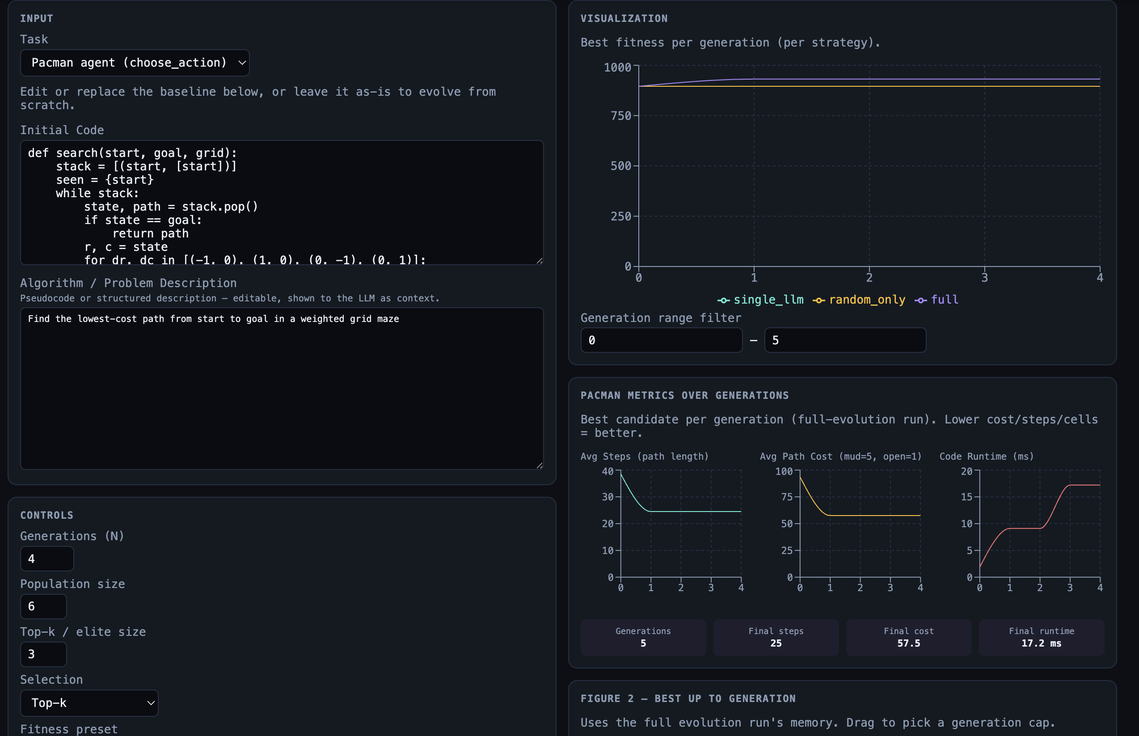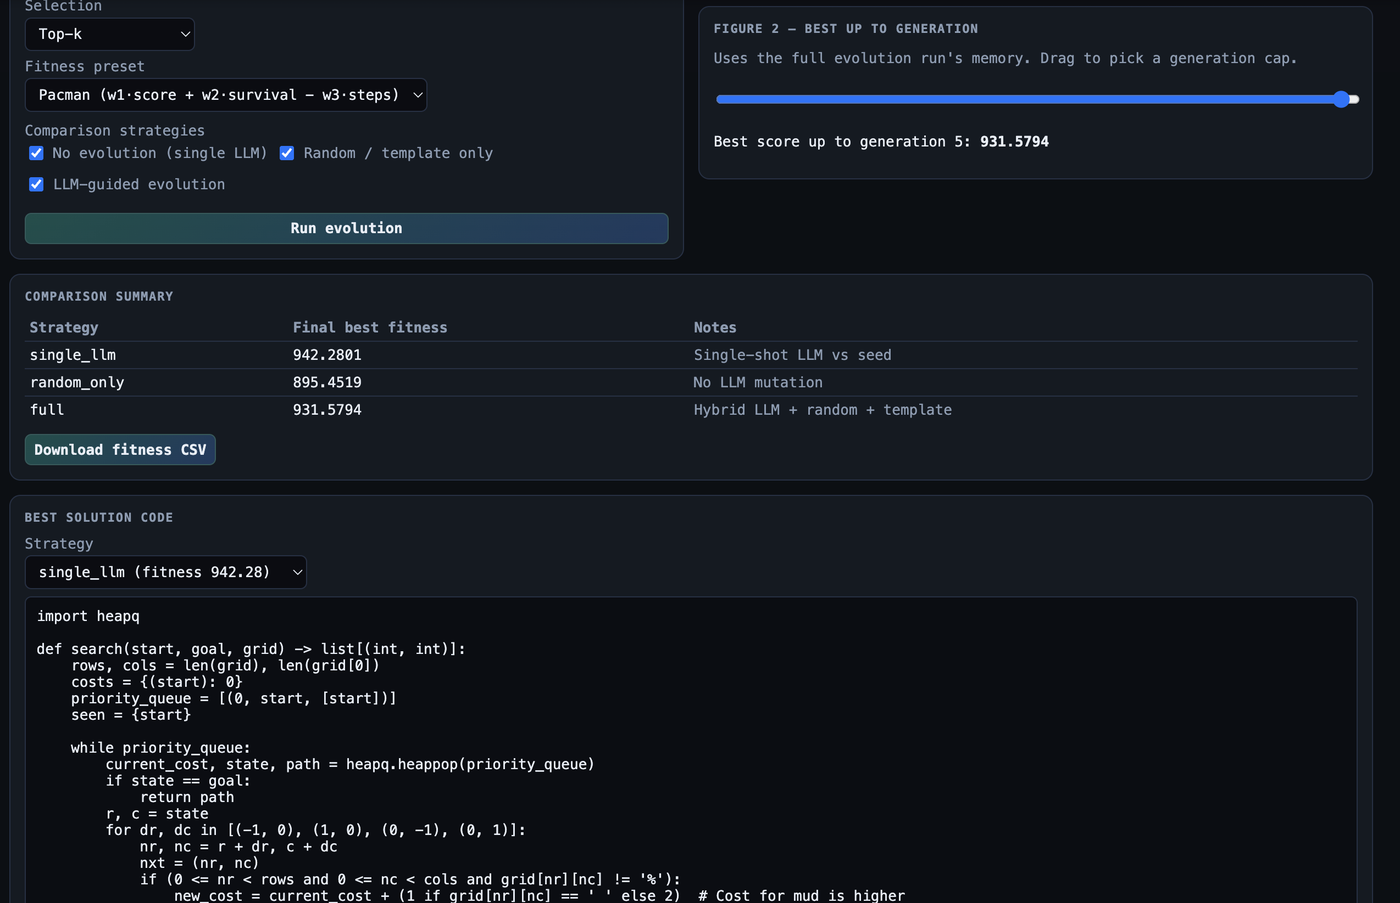
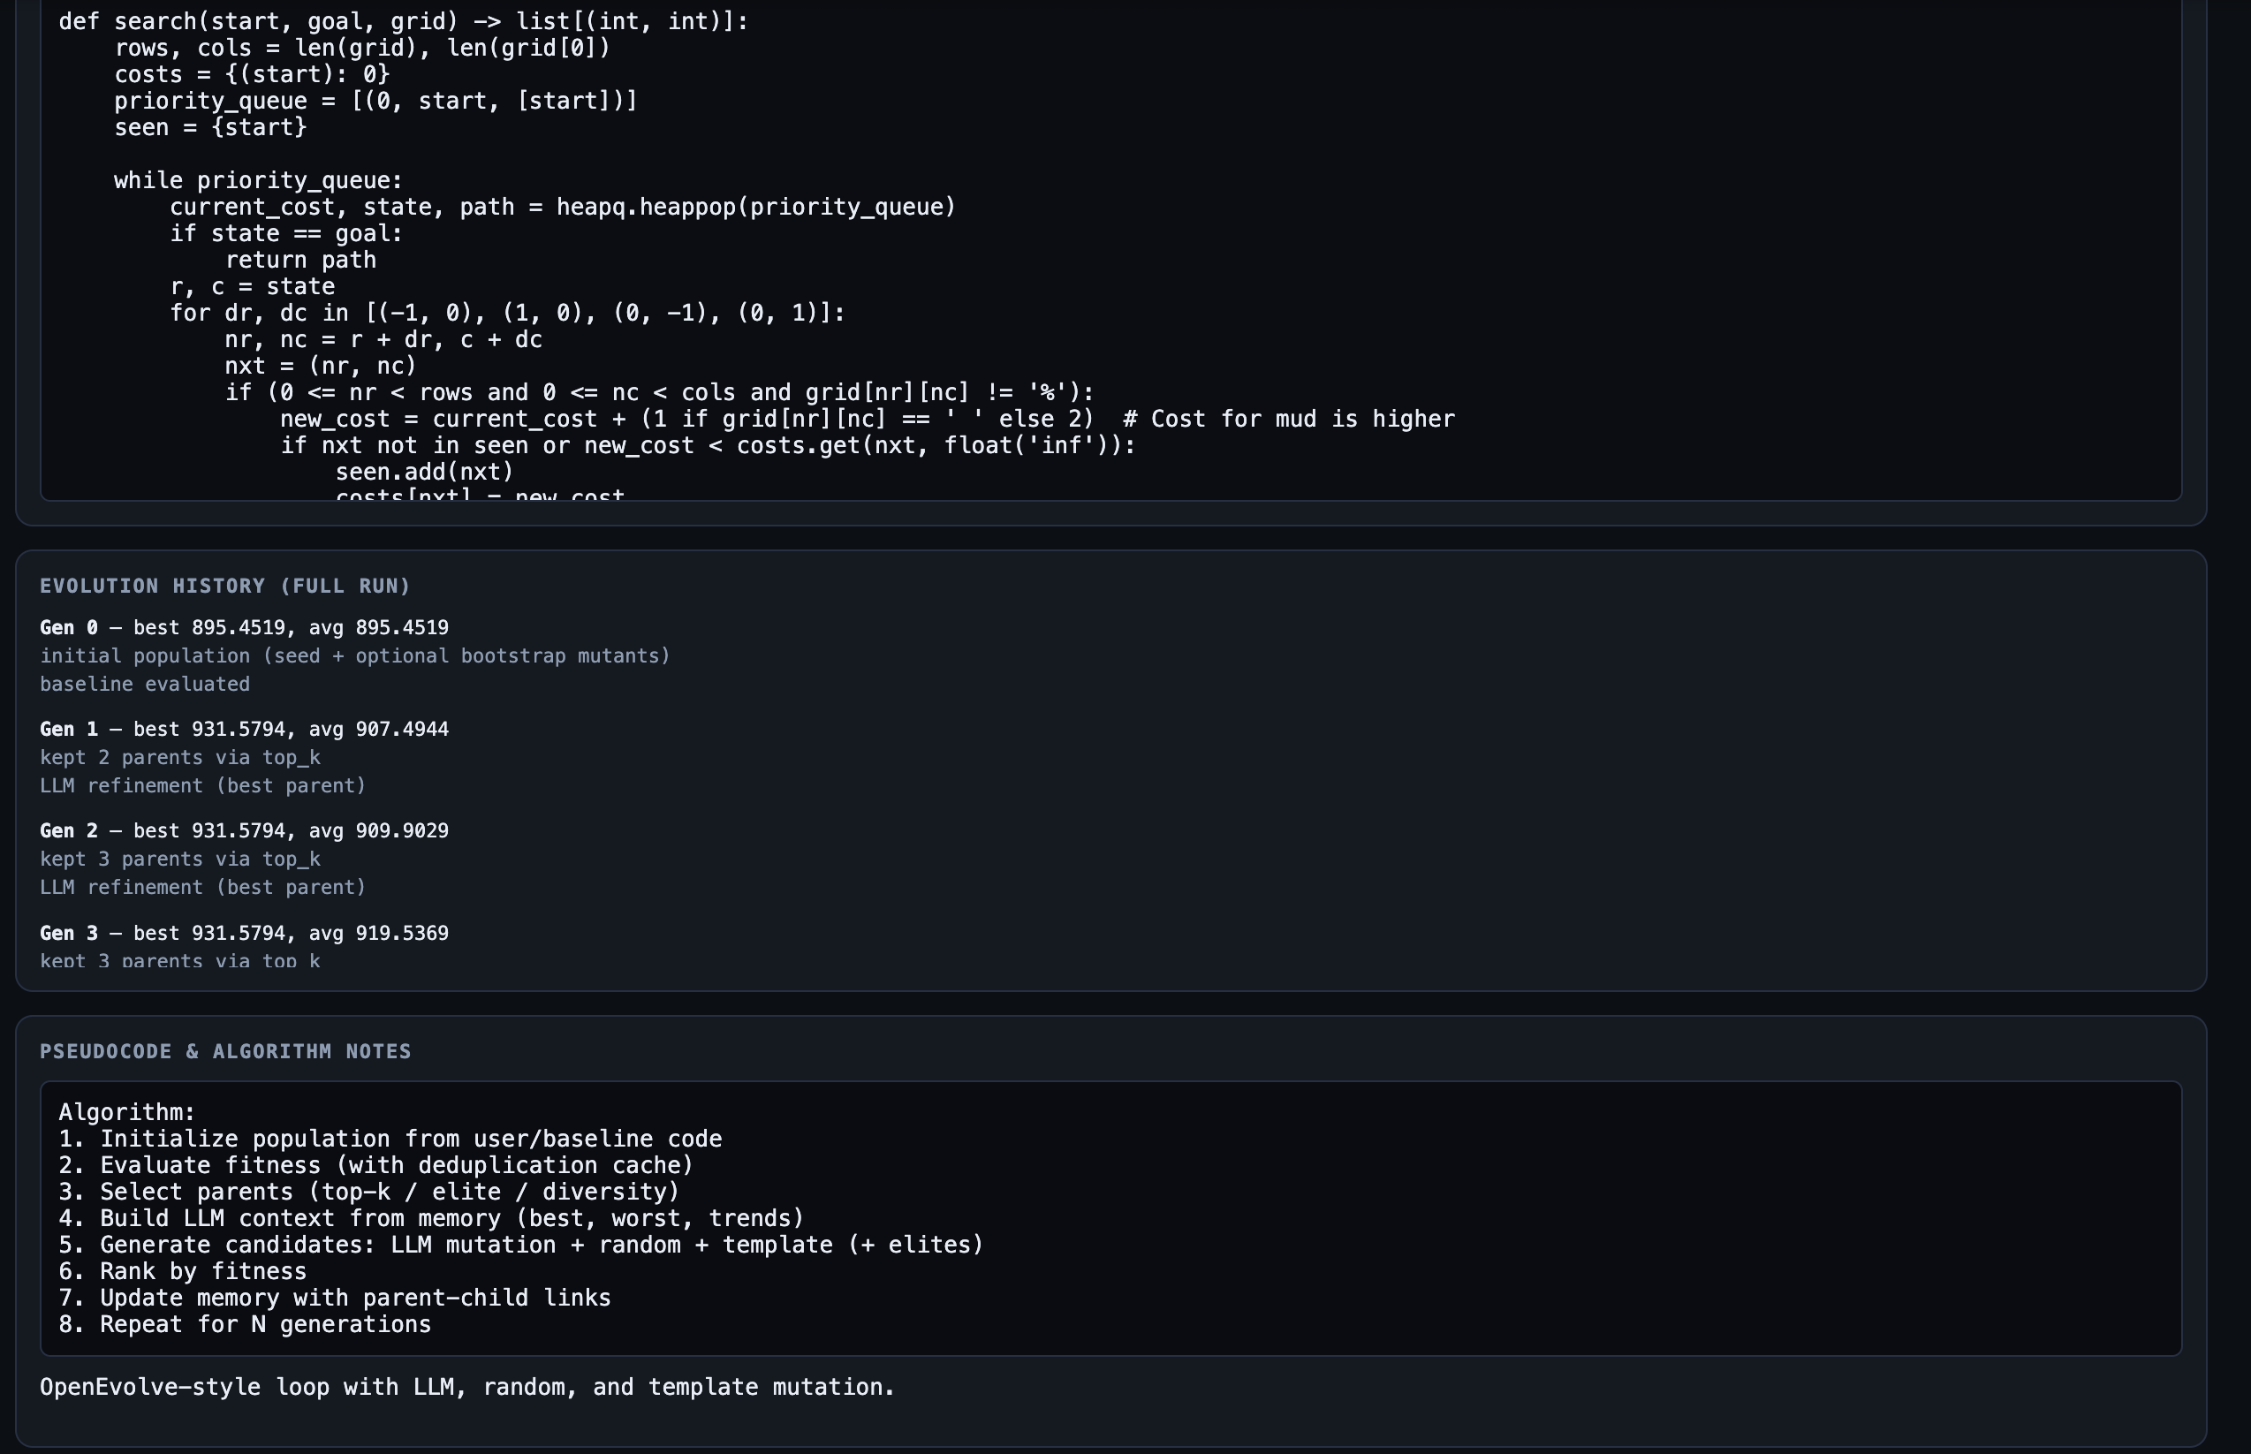

2. Runtime Performance
Here is the eval_time_ms for the best candidate each generation on the full evolution runs:
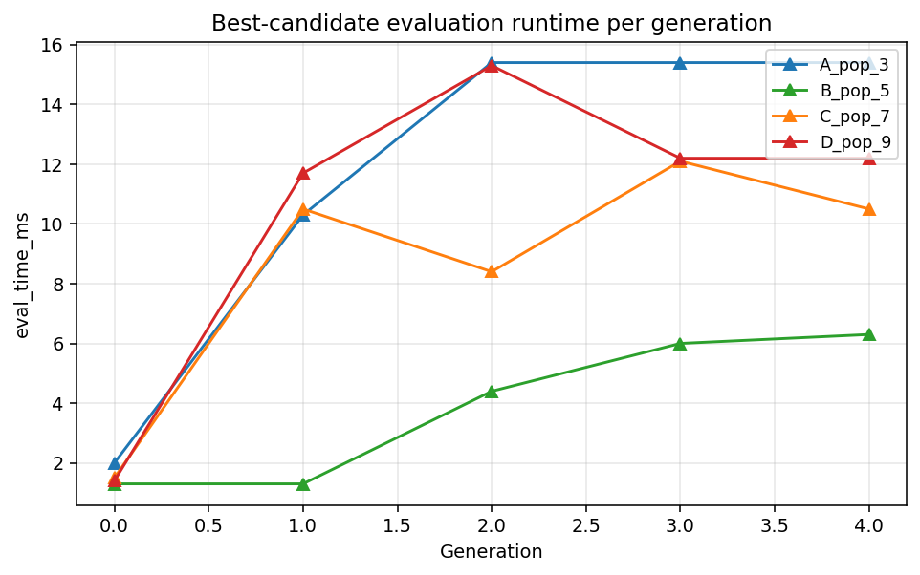
Config | Population Size | Full Final Best Fitness | Random_Only Final Best Fitness
A_pop_3 | 3 | 931.5794 | 895.4519
B_pop_5 | 5 | 961.0064 | 895.4519
C_pop_7 | 7 | 931.5794 | 895.4519
D_pop_9 | 9 | 931.5794 | 895.4519

3. Steps per Generation
Average steps taken by the best candidate each generation. Lower is better since it means the evolved path gets to the goal faster.
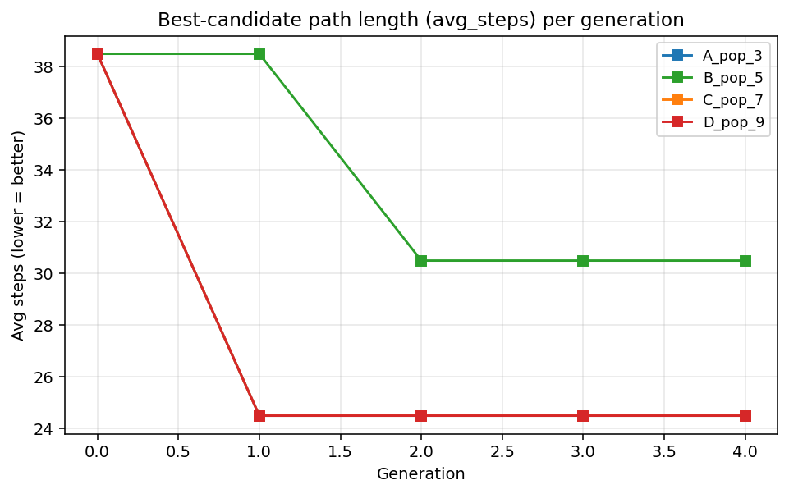

4. Generation Count

The results show that B_pop_5 achieved the strongest overall performance in the full evolution setting. Its best fitness remained at 895.4519 through generation 1, then increased sharply to 961.0064 at generation 2 and stayed there through generations 3 and 4. In contrast, A_pop_3, C_pop_7, and D_pop_9 all improved from 895.4519 at generation 0 to 931.5794 by generation 1, and then plateaued at that level for the rest of the run. This pattern suggests that a population size of 5 gave the algorithm enough diversity to discover a stronger solution than the smaller or larger tested populations within the same 4-generation limit. The random-only baseline did not show meaningful improvement and remained at 895.4519 in the final generation for all four configurations, confirming that the full LLM-guided evolution strategy was responsible for the gains observed in the experiment.

5. Fitness Scores Across Iterations
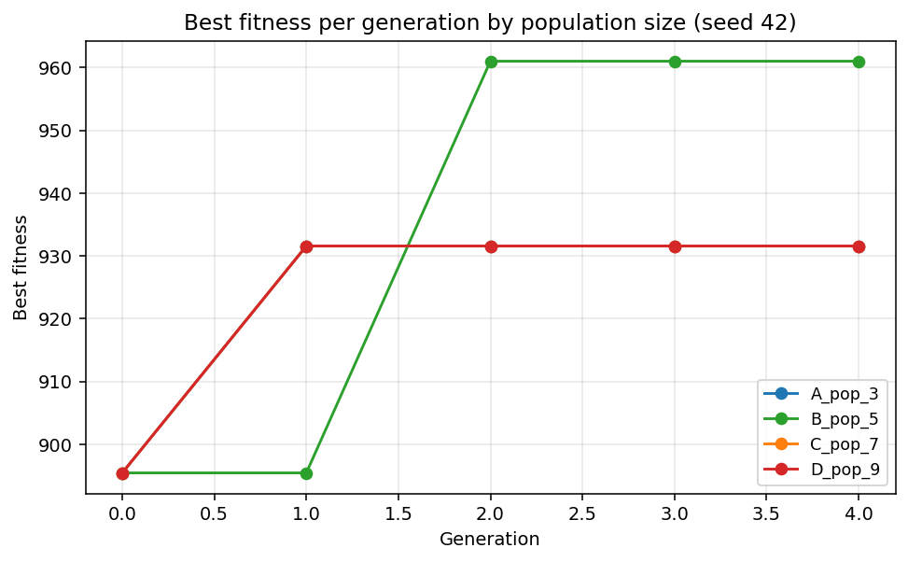
Final best fitness for each config (full evolution only):
Config | Population Size | Full Final Runtime (ms) | Random_Only Final Runtime (ms) | Config | Population Size | Full Final Runtime (ms)
A_pop_3 | 3 | 15.4 | 1.3 | A_pop_3 | 3 | 15.4
B_pop_5 | 5 | 6.3 | 1.3 | B_pop_5 | 5 | 6.3
C_pop_7 | 7 | 10.5 | 1.3 | C_pop_7 | 7 | 10.5
D_pop_9 | 9 | 12.2 | 1.2 | D_pop_9 | 9 | 12.2

6. Comparative Plot - Full Evolution vs Random-Only
The results show that B_pop_5 produced the strongest overall solution. In the final generation of the full evolution runs, A_pop_3, C_pop_7, and D_pop_9 each finished with an average of 24.5 steps and an average path cost of 57.5. In contrast, B_pop_5 finished with 30.5 average steps but a much lower path cost of 31.5, which corresponded to the highest final fitness of 961.0064. The random-only baseline performed much worse in every configuration, ending at 38.5 average steps and 93.5 average cost across all four tested population sizes. These results suggest that the population size of 5 allowed the system to evolve a strategy with substantially better path quality than either the smaller or larger population settings.

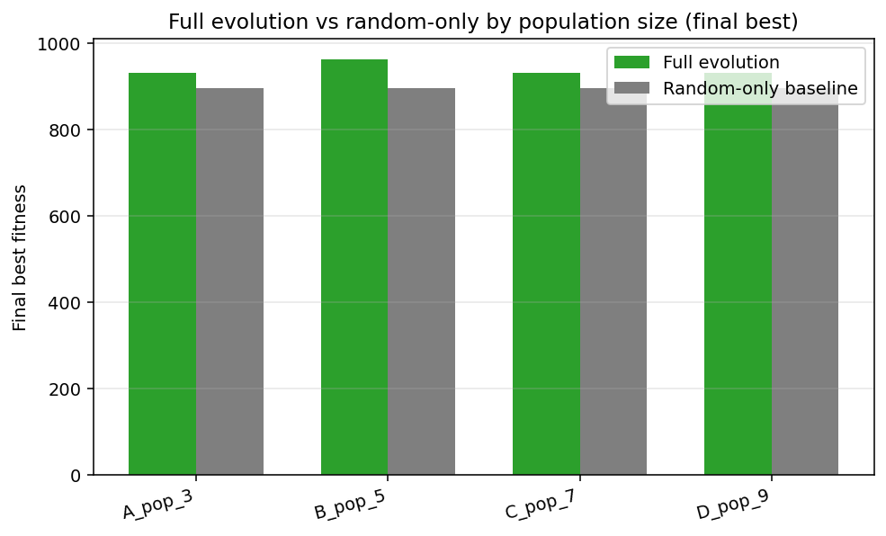
Config | Population Size | Full Final Avg Steps | Full Final Avg Cost | Random_Only Final Avg Steps | Random_Only Final Avg Cost
A_pop_3 | 3 | 24.5 | 57.5 | 38.5 | 93.5
B_pop_5 | 5 | 30.5 | 31.5 | 38.5 | 93.5
C_pop_7 | 7 | 24.5 | 57.5 | 38.5 | 93.5
D_pop_9 | 9 | 24.5 | 57.5 | 38.5 | 93.5

7. Analysis

What stands out pretty clearly is that the full strategy consistently did better, but the amount of improvement depended on the population size. For A_pop_3, C_pop_7, and D_pop_9, the final best fitness reached 931.5794, which is 36.1275 points higher than the random-only result of 895.4519. The strongest result came from B_pop_5, where the full strategy reached 961.0064, outperforming the random-only baseline by 65.5545 points. This makes B_pop_5 the most effective configuration in the experiment. Overall, the comparison suggests that the LLM-guided evolution process was genuinely useful and that a moderate population size gave it the best chance to discover a higher-quality solution within only four generations.

8. Issues, Suggestions, Feedback

One issue I noticed is that larger population sizes did not automatically lead to better performance, even though they require more evaluation work and longer runtimes. In this sweep, the moderate setting B_pop_5 performed better than both the smaller and larger populations, which suggests that simply increasing the number of candidates is not always the best use of resources in a short run. A useful improvement for future versions of the project would be to add more built-in support for batch experiments in the frontend, such as saving parameter presets or automatically comparing multiple runs side by side. That would make it easier to collect screenshots and data without relying as much on separate scripts. Overall, the most helpful part of the system was being able to compare the full evolution strategy directly against the random-only baseline. That comparison made it much easier to see that the LLM-guided approach was actually contributing meaningful improvement instead of just producing random variation.

Appendix. Raw Data Reference
The raw per-generation results for this experiment are stored in jacob_ray_data.csv, which is included with this report. Each row in the file represents one (config, strategy, generation) combination from the population-size sweep. The columns in the CSV are config, population_size, strategy, generation, best_fitness, avg_fitness, best_avg_score, best_avg_cost, best_avg_steps, best_avg_cells_accessed, best_eval_time_ms, and best_success_rate. These values were used to create the comparison tables, charts, and analysis presented in the report.

